**Assignment 1: Application DOG API**

**Test plan for TODO Application**

Test Environment:

* Browser: Chromium family
* Operating System: Ubuntu

Test Scope:

The test plan covers only the happy paths for the functionalities of TODO application. The main functionalities includes task creation, task edit, task status, task deletion and task status views.

Functionality check:

1. Task Creation

* Users should be able to add a new task.
* Created task should be visible in the list.
* New tasks created should be visible in the All and Active status tabs.

1. Task Edit

* Users should be able to edit the task by double clicking on the task name.
* After the editing the changes should be reflected in the list.

1. Task Status

* User should be able to mark the status of the task by clicking on the radio button.
* Completed task should be visible under the completed tasks list.

1. Task Deletion

* User should be able to delete the task.
* Deleted task should be removed from the task list.

1. Task Status Views

* When the user selects All status all the tasks should be visible.
* When the user selects Active status only the active tasks should be visible.
* When the user selects Completed status only the completed tasks should be visible.

**Test Use Cases for “Task Deletion” and “Task Edit” features using BDD Language:**

Task Deletion:

* Given task “Run to the door”
* When user click on the cross mark next to the task “Run to the door”
* Then “Run to the door” task should be removed from the list

Task Edit:

* Given a task “Pay water bill” in the task list
* When user edits “Pay water bill” to “Pay all the water bills”
* Then “Pay water bill” should be updated with “Pay all the water bills”

Bug Report:

* When all the items are selected “1 item left” message is displayed.
* When the user is selecting one task item, the other task is also being selected.
* When user is selecting a task, the tasks are getting greyed out except one.

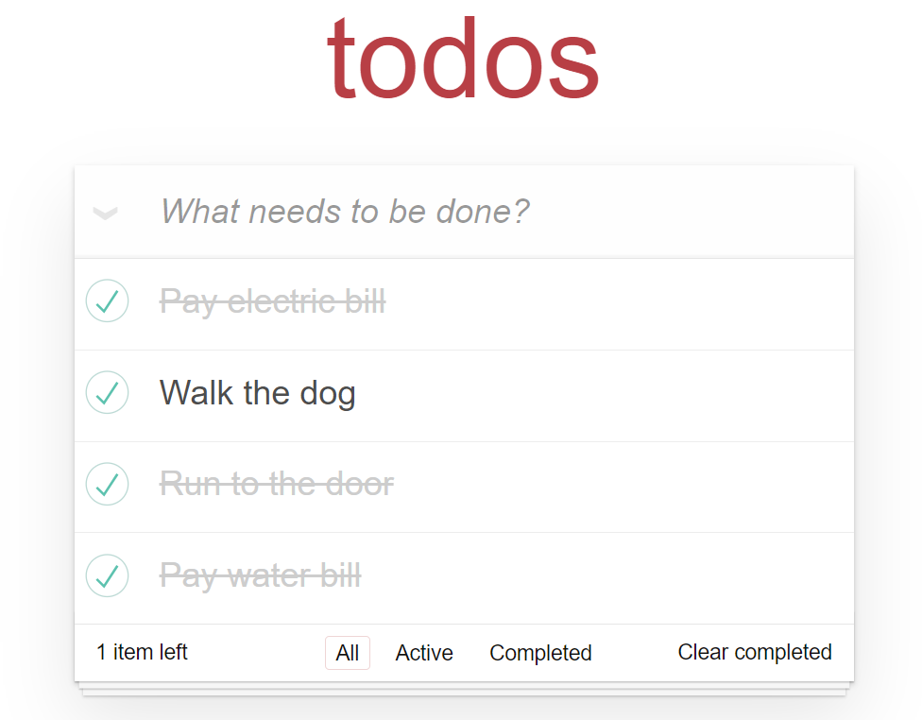

Enhancement:

* Edit option can be used instead of double click.
* Delete icon can be added instead of cross mark to delete the task.

Test Strategies:

* Regression testing.
* Smoke testing.
* Sanity testing.
* End-to-end testing.